DESIGN AND IMPLEMENTATION OF AN ONLINE PRISON MANAGEMENT SYSTEM
(A CASE STUDY OF NIGERIA PRISON SERVICE ENUGU)

ABSTRACT
Prisoners’ management in Nigeria has long been a neglected area and has only recently been included in the 20-20 vision document under the e-governance. Currently, prisoner’s records are maintained in a very rudimentary way in the form of manual files and registers. This method of data management often results in human error, delay to retrieve information etc. Thus, An Online Prison Management System was designed and implemented to manage prisoner’s records for the Nigerian prison service Enugu command. This project was done using basic html for visible web contents, php for server scripting and MySQL database was used to store and manage the prisoner’s records. Tools used to achieve this Project includes Dreamweaver CS5 html editor,CSS3 for styling, JavaScript, php wamp5 server and MySQL. The project was implemented successfully and the result obtained provides a single management system which integrates all the information about a prisoner in a single profile and can easily be accessed which improved the overall efficiency of prison management.

TABLE OF CONTENT
Certification………………………………………………………………………………….I
Dedication………………………………………………………………………………………Ii
Acknowledgement……………………………………………………………………….Iii
Abstract………………………………………………………………………………………….Iv
Table of content…………………………………………………………………………..v
List of Figures………………………………………………………………………………..VI
List of Tables………………………………………………………………………………….VII

CHAPTER ONE
INTRODUCTION
1.1 BACKGROUND OF THE STUDY……………………………..1
1.2 STATEMENT OF PROBLEM………………………………….2
1.3 OBJECTIVE OF THE STUDY…………………………………………………………3
1.4 SIGNIFICANCE OF THE STUDY…………………………….3
1.5 SCOPE OF THE STUDY………………………………………………………………4
1.6 LIMITATIONS OF THE STUDY……………………………………………………4
1.7 PROJECT REPORT ORGANIZATION ………………………5
1.8 DEFINITION OF TERMS…………………………………………………………….5
CHAPTER TWO
LITERATURE REVIEW
2.1 DATABASE MANAGEMENT SYSTEM…………………………………………6
2.2 MANAGEMENT INFORMATION SYSTEM (MIS)…………………………11
2.3 REVIEW OF PRISON MANAGEMENT SYSTEM ………………………….16
CHAPTER THREE
SYSTEM ANALYSIS
3.1 GENERAL ANALYSIS OF THE EXISTING SYSTEM………………………26
3.2 METHOD OF DATA COLLECTION…………………………………………….26
3.3 LIMITATIONS OF EXISTING SYSTEM………………………………………27
3.4 PROPOSED SYSTEM…………………………………………………………….. 27
3.5 ADVANTAGES OF PROPOSED SYSTEM………………………………….27
3.6 INPUT ANALYSIS…………………………………………………………………..28

CHAPTER FOUR
SYSTEM DESIGN AND IMPLEMENTATION
4.1 OBJECTIVE OF DESIGN……………………………………………………………29
4.2 INPUT SPECIFICATION AND DESIGN………………………………………..30
4.3 OUTPUT SPECIFICATION AND DESIGN………………………………………31
4.4 MAIN MENU DESIGN………………………………………………………………32
4.5 DATABASE FILE DESIGN …………………………………………………………33
4.6 PROGRAM MODULES SPECIFICATION……………………………………34
4.7 SYSTEM FLOWCHARTS……………………………………………………………35
4.8 PROGRAM FLOWCHART…………………………………………………………36
4.9 CHOICE OF PROGRAMMING LANGUAGE ………………………………37
4.10 SYSTEM REQUIREMENT…………………………………………………………37

CHAPTER FIVE
SUMMARY, CONCLUSION AND RECOMMENDATIONS
5.1 SUMMARY…………………………………………………………………………………..43
5.2 CONCLUSION……………………………………………………………………. ………44
5.3 RECOMMENDATIONS…………………………………………………………………….45

REFERENCES…………………………………………………………………….47
APPENDIX A (SOURCE CODE)………………………………………………………………48

CHAPTER ONE
INTRODUCTION

1.1 BACKGROUND OF THE STUDY
Management of prisons in Nigeria has long been a neglected area which has recently been incorporated in the e-governance program of Government of Nigeria. Currently a rudimentary process of storing all the prisoner data in manual files and registers is in place. The Prison Management System project will integrate all the prisoner data into a single integrated system which will in turn result all the information being present in a digital format.
ICT in prisons was initiated in the year 2002 at Delhi Prisons, Tihar. The Tihar Prisons Complex in New Delhi is the biggest prison complex in Asia comprising of 9 prisons and one District Jail at Rohini with a total strength of more than 11,000 prisoners against a normal sanctioned capacity of 6250 prisoners. In a year about 70,000 - 80,000 inmates remain lodged in these prisons for different duration and crimes committed by them. This prison population has about 80% under trials and includes about 480 women inmates. About 400 inmates are foreigners from different parts of the world. Many high security criminals also live here. There has been a substantial increase in number of prison inmates coming to Tihar because of a phenomenal increase in the crime scene at Delhi that has resulted in the increase of the ICT needs and its management at the Tihar Jail Complex.
Nearly 1700-1800 visitors meet their relative inmates’ everyday. There was manual system of booking (meetings) in each jail for its respective inmates. Centralised visitor record was not available. There was lack of exchange of visitors’ information within jails and prison headquarters. No provision for identification / detection / verification of visitors was there.
Managing the prisoner record and monitoring of prisoner / visitor was always difficult since most of the records were normally maintained manually, so the concerned authorities were required to go through all the registers to find out the details and status of the inmate as well as of the visitor.
In order to cope up with the increasing number of prisoners being lodged in, the Tihar Administration required a re-engineering and rationalization of their key business processes and functions of prisoners’ related information and their computerization in order to speed up the processing of information need of courts and various other national agencies.
As the technology evolution is taking place, there arose a need for centralization of prisoner’s data to facilitate information exchange and data sharing to the users of the prison. It shall reduce administrative overheads, speed up responsiveness to users, reduce risks involved in inmate’s custody, eliminated obsolete processes and reap costcutting benefits.

1.2 STATEMENT OF PROBLEM
Management of prison’s in Nigeria is still at a nascent stage and follows rudimentary processes. Most of the prisons in Nigeria have a collection of manual files and registers to store prisoner/criminal records. This is a very inefficient and cumbersome way of storing records which greatly impedes the flow of critical information as well as makes looking up of information time consuming. Also, different files and registers are required to store the information which is relevant to a single prisoner. This hinders the profiling process of prisoners.

1.3 OBJECTIVE OF THE PROJECT
The main purpose behind the implementation of the Prison Management System (PMS) was to enhance the administrative capabilities of the jails in terms of monitoring and security of the prison while improving the efficiency and productivity of the Prisons.
The main goals of the project are enunciated below:
- To ensure proper monitoring of the prisons by the top officials
- To ensure that the discipline and decorum of the jails is maintained by both the employees and the prisoners
- To ensure that no impersonation of the prisoners happens by proper validation and authentication of the prisoner’s identity
- To improve the productivity and efficiency of the prisons so as to facilitate the usage of the available work force for sensitive work while leveraging technology to reduce the mundane workload of the employees
- To ensure the availability of data in digital form for preservation, analysis and reporting.

1.4 SIGNIFICANCE OF THE PROJECT
The nature of project is such that outcome of project could be quantitatively measured only for few parameters such as
- Automatic detection of duplication
- Immediate generation of report on categorization of prisoners on basis of their cases, period of confinement etc.
- Automatic calculation of Remission to be granted to a convict prisoner for good behavior, discipline etc.
- Reduction in the cost (Saving of resources) of physical production of prisoners in Courts.

1.5 SCOPE OF THE PROJECT
The basic purpose of this project is to develop an online system for prison management. The system developed covers prisoner’s information such as picture, conviction, offence, visitors, address, jail term record etc.

1.6 LIMITATIONS OF THE PROJECT
Generally, a study of this nature would have some constraints such as time, money and data collection method. I wish to say that data collection method used has the limitation of rigidity (people finding it difficult to respond to questions) thereby restricting the information obtained.

Also lack of finance is another obstacle that hindered a wider consultations and research on the project. Some materials may have some cost implications which may be above the budgeted money for the research work.

1.7 PROJECT REPORT ORGANIZATION
The project is organized as follows;-
Chapter one introduces the background of the project with the statement of the problems, objectives of the project, its significance, scope, and constraints are pointed out. Previous literatures on prison management information system were reviewed in Chapter two. Chapter three discusses system Investigation and Analysis. It deals with detailed investigation and analysis of the existing system and problem identification. It also proposed for the new system. Chapter four covers the system design and implementation. Chapter five was the summary and conclusion of the project.

1.8 DEFINITION OF TERMS
Data- This can be defined as facts about the organization and its business transaction.
Information- This can be defined as data that has been transformed and organized by processing and purposeful intelligence.
Information system- This is an arrangement of people, data, processes and interface that interact to support and improve day to day operation in a business as well as support the problem solving and decision making needs for management and users.
Management: It is the co-ordination of all the resources of an organization through the process of planning, organization, directing and controlling in order to attain organizational objectives.
CHAPTER TWO
LITERATURE REVIEW

2.1 DATABASE MANAGEMENT SYSTEM
The introduction of computer into information technology has massively improved the information need of organization; the success of this machine is dependent on the knowledge base.
A database is an organized collection of data. The data is typically organized to model relevant aspects of reality, in a way that supports processes requiring this information.
Database management systems (DBMS) are specially designed applications that interact with the user, other applications, and the database itself to capture and analyze data. A general-purpose database management system (DBMS) is a software system designed to allow the definition, creation, querying, update, and administration of databases. A database is not generally portable across different DBMS, but different DBMS can inter-operate by using standards such as SQL and ODBC or JDBC to allow a
single
Database management system is typical information processing system or organizational information system on people’s information. World Net describes an information system (I.S) as “a system consisting of the network of all communication channels used within an organization, and includes software and hardware”. It may also be defined as “a system that collects and processes data (information) and provides it to mangers at all levels that use it for decision making, planning, program implementation and control.
The aim of information system in immigration is improving the quality and accuracy of information provided to all involved as well as assisting management in compiling and reporting information.
Computerization is a social process for providing access to and support for computer equipment to be used in activities such as teaching, accounting, writing, designing, circuits, file processing etc. computerization entails social choices about the levels of appropriate investment and control over equipment and expertise, as well as choices of equipment.
Dunlop and Kling (1991), by the early 1990s, computing and telecommunications accounted for half of the capital investments made by private firms. However, paper (1980), Feigenbaum and McCorduck (1983) and Yourdon (1986) stated that the most fervent advocates of computerization have argued that the actual pace of computerization in schools, factories and homes is too slow.
King (1986), others emphasize a labour-market pragmatism that we label “vocational matching”. In this view, people will need computer skills, such as programming, to compete in future labour markets and to participate in a highly automated society; a responsible school will teach some of these skills today. Kling (1986), advocate of computer- based education promote a utopian image of computer- using schools as places where students learn in a cheerful, cooperative setting and where all teachers can be supportive, enthusiastic mentors.
Therefore, a computerized database management system is usually a system, which is implemented with a computer to achieve the utmost efficiency and desired goals. Russell, M. (1987) dealt extensively on the need for the use of computers on such database system like database management system. In the words of David (2003), at the center of any information system is a database, which is any collection of related information grouped together as a simple item. The term can also apply to the ways in which information is catalogued, analyzed, stored and used manually.
Database management systems (DBMS) have become a standard tool for shielding the computer user from details of secondary storage management. They are designed to improve the productivity of application programmers and to facilitate data access by computer-naive end users. There have been several database models. Whichever conceptual model or database management system is adopted, the use of a central database management system has a number of advantages and some costs compared to the commonly employed special purpose data files. A data file consists of a set of records arranged and defined for a single application system. Relational information between items in a record or between records is not explicitly described or available to other application systems. For example, a file of project activity durations and scheduled times might be assembled and manipulated by a project scheduling system. This data file would not necessarily be available to the accounting system or to corporate planners.
A centralized DBM has several advantages over such stand-alone systems:
- Reduced redundancy good planning can allow duplicate or similar data stored in different files for different applications to be combined and stored only once.
- Improved availability information may be made available to any application program through the use of the DBM
- Reduced inconsistency if the same data is stored in more than one place, then updating in one place and not everywhere can lead to inconsistencies in the database.
- Enforced data security authorization to use information can be centralized.
For the purpose of project management, the issue of improved availability is particularly important. Most application programs create and own particular data files in the sense that information is difficult to obtain directly for other applications. Common problems in attempting to transfer data between such special purpose files are missing data items, unusable formats, and unknown formats.
As an example, suppose that the Purchasing Department keeps records of equipment rental costs on each project underway. This data is arranged so that payment of invoices can be handled expeditiously and project accounts are properly debited. The records are arranged by individual suppliers for this purpose. These records might not be particularly useful for the purpose of preparing cost estimates since:
- Some suppliers might not exist in the historical record.
- Finding the lowest cost supplier for particular pieces of equipment would be exceedingly tedious since every record would have to be read to find the desired piece of equipment and the cost.
- No direct way of abstracting the equipment codes and prices might exist.
An alternative arrangement might be to separately record equipment rental costs in (1) the Purchasing Department Records, (2) the Cost Estimating Division, and (3) the Company warehouse. While these multiple databases might each be designed for the individual use, they represent considerable redundancy and could easily result in inconsistencies as prices change over time. With a central DBM, desired views for each of these three users could be developed from a single database of equipment costs.
A manager need not conclude from this discussion that initiating a formal database will be a panacea. Life is never so simple. Installing and maintaining databases is a costly and time consuming endeavor. A single database is particularly vulnerable to equipment failure. Moreover, a central database system may be so expensive and cumbersome that it becomes ineffective; we will discuss some possibilities for transferring information between databases in a later section. But lack of good information and manual information management can also be expensive.
One might also contrast the operation of a formal, computerized database with that of a manual filing system. For the equipment supplier example cited above, an experienced purchasing clerk might be able to immediately find the lowest cost supplier of a particular piece of equipment. Making this identification might well occur in spite of the formal organization of the records by supplier organization. The experienced clerk will have his (or her) own subjective, conceptual model of the available information. This subjective model can be remarkably powerful. Unfortunately, the mass of information required, the continuing introduction of new employees, and the need for consistency on large projects make such manual systems less effective and reliable.

2.2 MANAGEMENT INFORMATION SYSTEM (MIS)
The concept of the MIS has evolved over a period of time comprising many different facets of the organizational function. MIS is a necessity of all the organizations. The initial concept of MIS was to process data from the organization and presents it in the form of reports at regular intervals. The system was largely capable of handling the data from collection to processing. It was more impersonal, requiring each individual to pick and choose the processed data and use it for his requirements. This concept was further modified when a distinction was made between data and information. The information is a product of an analysis of data. This concept is similar to a raw material and the finished product. What are needed are information and not a mass of data. However, the data can be analyzed in a number of ways, producing different shades and specifications of the information as a product. It was, therefore, demanded that the system concept be an individual- oriented, as each individual may have a different orientation towards the information. This concept was further modified, that the system should present information in such a form and format that it creates an impact on its user, provoking a decision or an investigation. It was later realized then even though such an impact was a welcome modification, some sort of selective approach was necessary in the analysis and reporting. Hence, the concept of exception reporting was imbibed in MIS. The norm for an exception was necessary to evolve in the organization. The concept remained valid till and to the extent that the norm for an exception remained true and effective. Since the environment turns competitive and is ever changing, fixation of the norm for an exception becomes futile exercise at least for the people in the higher echelons of the organization. The concept was then evolved that the system should be capable of handling a need based exception reporting. This need maybe either of an individual or a group of people. This called for keeping all data together in such a form that it can be accessed by anybody and can be processed to suit his needs. The concept is that the data is one but it can be viewed by different individuals in different ways. This gave rise to the concept of DATABASE, and the MIS based on the DATABASE proved much more effective.
Over a period of time, when these conceptual developments were taking place, the concept of the end user computing using multiple databases emerged. This concept brought a fundamental charge in MIS. The change was decentralization of the system and the user of the information becoming independent of computer professionals. When this becomes a reality, the concept of MIS changed to a decision making system. The job in a computer department is to manage the information resource and leave the task of information processing to the user. The concept of MIS in today’s world is a system which handles the databases, databases, provides com-putting facilities to the end user and gives a variety of decision making tools to the user of the system.
The concept of MIS gives high regard to the individual and his ability to use information. An MIS gives information through data analysis. While analyzing the data, it relies on many academic disciplines. These include the theories, principles and concepts from the Management Science, Psychology and Human Behavior, making the mis more effective and useful. These academic disciplines are used in designing the MIS, evolving the decision support tools for modeling and decision - making.
The foundation of MIS is the principles of management and if its practices. MIS uses the concept of management Information System can be evolved for a specific objective if it is evolved after systematic planning and design. It calls for an analysis of a business, management views and policies, organization culture and the culture and the management style. The information should be generated in this setting and must be useful in managing the business. This is possible only when it in conceptualized as system with an appropriate design. The MIS, therefore, relies heavily on the systems theory offers solutions to handle the complex situations of the input and output flows. It uses theories of communication which helps to evolve a system design capable of handling data inputs, process, and outputs with the lest possible noise or distortion in transmitting the information form a source to a destination. It uses the principles of system Design, Viz., an ability of continuous adjustment or correction in the system in line with the environmental change in which the MIS operates. Such a design help to keep the MIS tuned with the business managements needs of the organization.
The concept, therefore, is a blend of principle, theories and practices of the
Management, Information and System giving rise to single product known as Management Information System (MIS).
The Physical view of the MIS can be seen as assembly of several subsystems based on the databases in the organization. These subsystems range from data collection, transaction processing and validating, processing, analyzing and storing the information in databases. The subsystem could be at a functional level or a corporate level. The information is evolved through them for a functional or a department management and it provides the information for the management of business at the corporate level.
The MIS is a product of a multi- disciplinary approach to the business management. It is a product which needs to be kept under a constant review and modification to meet the corporate needs of the information. It is prescribed product design for the organization. The MIS differs since the people in two organizations involved in the same business. The MIS is for the people in the organization. The MIS model may be the same but it differs greatly in the contents. The MIS, therefore, is a dynamic concept subject to change, time and again, with a change in the business management process. It continuously interacts with the internal and the external environment of the business and provides a corrective mechanism in the system so that the change needs of information are with effectively. The MIS, therefore, is a dynamic design, the primary objectively. The MIS, therefore, is a dynamic design the primary objective of which is to the information the information for decision making and it is developed considering the organizational fabric, giving due regard to the people in the organizational the management functions and the managerial and the managerial control.
The MIS model of the organization changes over a time as the business passes through several phases of developmental growth cycle. It supports the management of the business in each phase by giving the information which is crucial in that phase. Every has critical success factors in each phase of growth cycle and the MIS model gives more information on the critical success factors for decision making.
The role of the MIS in an organization can be compared to the role of heart in the body. The information is the blood and MIS is the heart. In the body the heart plays the role of supplying pure blood to all the elements of the body including the brain. The heart works faster and supplies more blood when needed. It regulates and controls the incoming impure blood, processes it and sends it to the destination in the quantity needed. It fulfills the needs of blood supply to human body in normal course and also in crisis.
The MIS plays exactly the same role in the organization. The system ensures that an appropriate data is collected from the various sources, processed, and sent further to all the needy destinations. The system is expected to fulfill the information needs of an individual, a group of individuals, the management functionaries: the managers and the top management.
The MIS satisfies the diverse needs through a variety of systems such as Query Systems, Analysis Systems, Modeling Systems and Decision Support Systems the MIS helps in Strategic Planning, Management Control, Operational Control and Transaction Processing.
The MIS helps the clerical personnel in the transaction processing and answers their queries on the data pertaining to the transaction, the status of a particular record and references on a variety of documents. The MIS helps the junior management personnel by providing the operational data for planning, scheduling and control, and helps them further in decision making at the operations level to correct an out of control situation. The MIS helps the middle management in short them planning, target setting and controlling the business functions. It is supported by the use of the management tools of planning and control. The MIS helps the top management in goal setting, strategic planning and evolving the business plans and their implementation.
The MIS plays the role of information generation, communication, problem identification and helps in the process of decision making. The MIS, therefore, plays a vital role in the management, administration and operations of an organization.

2.3 REVIEW OF PRISON MANAGEMENT SYSTEM
Automating and streamlining the process of prisoner / visitor movement at Prisons. Followings are the accomplishment in this area of prison management:
- Establishment of LAN: Establishment of LAN connecting all prisons situated in a big wide spread complex using 5,500 meters of Optical Fiber Cable (12 and 6 core) operated with one Layer - 3 switch supported by 16 Layer - 2 switches in the entire jail complex.
The network has 185 IOs and can be expanded to 300 nodes without any additions / modifications / disruptions to the existing infrastructure. Surveys were got conducted and laying of OFC was found to be the best suitable option;
- Development and Implementation of PMS: Prison Management System (PMS) comprises of 12 primary functional modules. More than 65 reports of various types have been developed under Client / Server architecture. It has been developed, tested and implemented. This PMS is having following major features:
  - Based on Client-Server Architecture and supporting latest GUI features;
  - Centralized Database for supporting powerful & fast retrieval of data;
  - Monitors physical location of inmate, their movements within and outside the jail complex, punishments, medical history of the inmate at the time of his / her arrival at the jail, cases filed against him, court hearings among other attributes; and
  - Supports more than 65 reports as per the present needs of the various monitoring agencies like National Human Rights Commission, National Crime Records Bureau and Tihar Jail itself.
- Biometric Tools: The PMS has been integrated with biometrics tools, which stores inmate’s biometric details at the time of entry and shall be used to authenticate him at the time of their movement. The biometric based verification and authentication system is installed in all 9 jails of Tihar Prisons Complex and at District Jail, Rohini, New Delhi with facility to store prisoner photograph. Tihar Prisons was the first prison using this technology for prisoner’s identification and verification along with the photograph; 4) Photo pass for visitors: Visitor Management System [VMS] is implemented at Central
Public Relation Office situated at Gate # 3 and at Gate # 4 of the Tihar Prisons. All visitors coming to Jail to meet their relative prisoners are first being photographed and then they are issued photo pass. Details of the visitors are being kept in the database and this information is shared with police for the investigation purpose. The meeting slip is generated within 45 seconds. The booking is using the concept of call centre. ISO Certification has been obtained for this process;
- Videoconferencing: The use of videoconferencing facility in prisons has drastically reduced expenditure incurred as compared to being physically producing the jail inmates in the courts. Physical production of an inmate require transportation, escort by armed police personnel, prevention of fights between inmates and nearly 6 hours of time wasted by each inmate. Fear of custody break is always there during the physical production.
There are incidents when prisoners have fled after breaking lockups in the courtroom or from the custody of armed security personnel escorting them to court or by armed attack on the police vans by daredevils. In some cases, there are incidents of clashes between the prisoners inside the lockup vans during transportation. There is sometimes remote possibility that inmate may get changed during transportation, which keeps the number intact but inmate is changed. By the use of videoconferencing, there is a check on all such incidents; and
- Cameras: Using analog and digital cameras security has been enhanced in the Tihar Prison complex. Cameras have been installed at strategic locations within wards, inside high security cells, at meeting points and at dheodi, where inmates are searched whenever they are escorted out of jail or are brought inside the jail complex. Each and every inmate can be watched from a video wall and surveillance brief is also sent to DG
(Prisons) in real time. These video graphed shots are produced in case of any disputes.

2.4 HUMAN RESOURCE MANAGEMENT (HRM)
The term ‘Human Resource Management’ has been the subject of considerable debate, and its underlying philosophy and character are highly controversial. Much of this controversy stems from the absence of a precise formulation of and agreement on its significance and definition (Storey, 1995), as cited by Bratton and Gold (2003).
Obviously, definition of the subject matter is needed for analysis and understanding of HRM theory and practice.
HRM has a variety of definitions but there is general agreement that it has a closer fit with business strategy than previous models, specifically personnel management. In all the debates about the meaning, significance and practice of HRM, nothing seems more certain than the link between HRM and performance (HRM Guide October 2006). Below are some of the definitions of HRM, although it can be argued that these will only be ones of several possible definitions.
De Cenzo and Robbins (1996) defined HRM as the part of the organization that is concerned with the people dimension, and it is normally a staff or support function in the organization. HRM role is the provision of assistance in HRM issues to line employees, or those directly involved in producing the organization’s goods and services. Acquiring people’s services, developing their skills, motivating them to high levels of performance, and ensuring their continuing maintenance and commitment to the organization are essential to achieving organizational goals. This is much the case regardless of the type of organization, government, business, education, health, recreation, or social action. The authors proposed an HRM specific approach as consisting of four functions- staffing, training and development, motivation, and maintenance.
In addition, Bratton and Gold (2003) define HRM as the strategic approach to managing employment relations which emphasizes that leveraging people’s capabilities is critical to achieving sustainable competitive advantage. This is achieved through a distinctive set of integrated employment policies, programs and practices. The authors presented HRM functions as planning, recruitment and selection, appraisal and performance management, reward management, development, employee relations, health and safety, and union-management relations. Moreover, to Alan Price (2004) HRM aims at recruiting capable, flexible and committed people, managing and rewarding their performance and developing key competencies.
Contributing to the working definition of HRM is Abecker et al., (2004). They see HRM as a strategic and target oriented composition, regulation and development of all areas that affect human resources in a company. Efficient and effective management of these resources to a large extend, affects human resource behavior, and consequently the performance of the organization as a whole. Moreover, the authors identified HRM with the field it covers. These include planning aspects- personnel requirements analysis and personnel asset analysis, and change aspects- recruitment, personnel development and labor displacement.
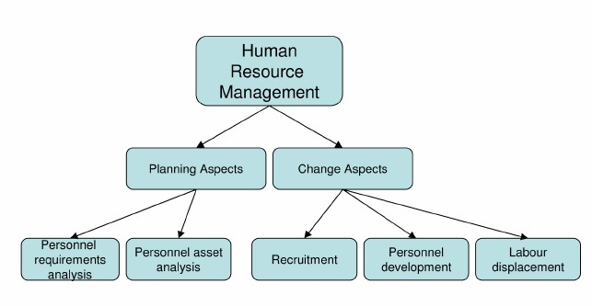
Figure2.1: Fields of HRM (Source: Abecker et al., 2004)
According to Torrington et al., (2005) HRM is fundamental to all management activity and has evolved from a number of different strands of thought. It is best described as a loose philosophy of people management rather than a focused methodology. Thus, distinction has been made between HRM as body of management activities on one hand (generically described as personnel management) and then on the other as a particular approach to execute those activities (carrying out people-oriented organizational activities than traditional personnel management).
An organization gains competitive advantage by using its employees effectively, drawing on their expertise and ingenuity to meet clearly defined objectives. Torrington et al., (2005) identified the role of the human resource functions with four key objectives.
These four objectives are the corner stone of all HR activities. These include Staffing, Performance, Change-management and Administration. Staffing objective focuses on finding the appropriate pool of human resources needed to ensure fully and timely supply of work force. It therefore involves designing organizational structures, identifying working conditions for different groups of employees followed by recruiting, selecting and developing the personnel required to fill the roles. Performance objective aims at ensuring workforce motivation and commitment for effective performance.

CHAPTER THREE

METHODOLOGY AND SYSTEM ANALYSIS

Methodology is the systematic, theoretical analysis of the methods applied to a field of study, or the theoretical analysis of the body of methods and principles associated with a branch of knowledge.

3.1 GENERAL ANALYSIS OF THE EXISTING SYSTEM
Management of prison’s in Nigeria is still at a nascent stage and follows rudimentary processes. Most of the prisons in Nigeria such as the Nigerian prison service Enugu, have a collection of manual files and registers to store prisoner/criminal records. This is a very inefficient and cumbersome way of storing records which greatly impedes the flow of critical information as well as makes looking up of information time consuming. Also, different files and registers are required to store the information which is relevant to a single prisoner. This hinders the profiling process of prisoners.

3.2 METHOD OF DATA COLLECTION
A thorough investigation of the current system was made in order to obtain detailed fact about the application area to be re-designed. Investigation also covered looking at the functional requirement of the present system and finding out whether the requirements and objective of the present system are being achieved. In the investigation proper, several methods of data collection were employed which includes interviewing of office representatives, evaluation/ inspection of forms and direct observation. These methods were adopted to ensure the validity of data collected and relevance of the result after processing the data.

3.2.1 Interviewing
In view to investigation, prison management staff were interviewed. This method yields the most profitable result as it is obtained by physical contacts, hence a firsthand knowledge of the various processes involved is obtained by speaking to the operator of the system. The essential element of the interview is obtained directly and in a short time than when other methods are employed since the interviewer is with the interviewed. This immediate feedback gives the opportunity to ask ambiguous questions and hence, obtain detailed responses.

3.2.2 Observation
The method of data collection enables the researchers to witness a firsthand operation of the old system or manual system. Direct observation is the surest method of learning as a scientist and this method was richly employed. This

3.3 LIMITATIONS OF EXISTING SYSTEM
The existing system has the following limitations;
- Inefficient organization of prison information and records.
- Information look up is cumbersome and time consuming.
- Impedes the flow of critical information.

3.4 PROPOSED SYSTEM
Taking in mind the above deficiencies, our project effectively deals with the above problems by providing a single integrated system where all the prison as well as prisoner/criminal information will be stored in a single centralized system having complete prisoner profiles. Each prisoner profile would have his/her demographic details, a digital photograph of the prisoner as well as his parole , visitor and number of times the prisoner has been out of prison with appropriate reason attached to it. This effectively scales down the time in which critical information has to be transferred to concerned agencies. Also maintenance of records is all the more easy as well as efficient when compared to the manual system.

3.5 ADVANTAGES OF PROPOSED SYSTEM
- Efficient organization of prison information and records
- Information look up is easy
- Substantially decreases the time in which critical information is passed on

3.6 INPUT ANALYSIS
This system would have two inputs from a user; Authentication and Prisoner details which would be stored in a Database. This database will contain all the information and necessary data required by the application for its functioning. The various tables in the database includes;
- Prisoners’ database: This will store all the necessary details pertaining to the prisoner profile e.g. Name, age, address etc.
- Users Database: This will store all the necessary information about the users of the application e.g. name, and password etc.

3.7 TOOLS
The tools used required to achieve this project includes a computer system,
Dreamweaver cs5, MySQL, PHP, and Apache server.
CHAPTER FOUR
SYSTEM DESIGN
System design is the process of creating a blue print for the proposed system in other words a prototype for the proposed system.

4.1 OBJECTIVE OF DESIGN
The system designed aimed at developing an online system that can be used by Nigerian prison to keep track of prison records. Security of the database used in the design was highly taken care of by the website developed. The objective of the design includes:
- Design software that can be used to stored prisoners information on database.
- Structure a database system that will store all the information.
- Design a query system to retrieve specified prisoners information
- Design a well formatted output that will present information in a meaningful format.
- Maintain a Database for prisoners jail term
- Ensure accuracy in the handling of data.

4.2 INPUT SPECIFICATION AND DESIGN
The system would require two input from users. The first login details for security and the new prisoner registration, which is entered through the keyboard.

4.2.1 Login input specification
The Login input would require users to input their login details for security of the system as seen in the diagram below. This module would contain two text input fields and a button.

Please
enter

your Log in details

Username:

Password:

LOGIN

Fig 4.1 Input specification for Login details: This design module, when implemented would be used to verify and authenticate users’ access to the management system.

4.2.2 Prisoner details input specification
The Prisoner’s details input would require users to input details for a new prisoner as seen in the design diagram below;

NEW PRISONER REGISTRATION

SURNAME:

JUDGEMENT:

OTHER NAMES
:

DATE:

SEX:

COURT:

ADDRESS:

VIRDICT:

OFFENCE:

SENTENCE:

SUBMIT

UPLOAD PRISONER’S
IMAGE

Fig 4.2 Prisoner details input specification: As seen in the design above this module when implemented would be used to input the details of a prisoner such as image, name, address, phone number etc.

4.3 OUTPUT SPECIFICATION AND DESIGN
The output form is designed to generate printable reports from the database. The output is placed on a database grid and contains prisoner’s information. The output produced can be printed on a hard copy or viewed on the screen.
PRISONER DETAILS
PRISONER’S
IMAGE
SURNAME: DATE OF JUDGEMENT

OTHER NAMES: PRISON NAME
SEX: COURT OF CONVICTION
ADDRESS: RELEASE DATE:
OFFENCE:
CRIME CODE:
Fig 4.3 Output design: As seen from the diagram this module when implemented would be used to view the details of a prisoner.
4.4 MAIN MENU DESIGN


Main Menu

HISTORY

UPDATE

ROLE OF
HONOUR

ABOUT US

DIRECTORATE

REGISTER PRISONER

EDIT PRISONER FILE

MGT SYSTEM

COMPLAIN
HOME

OPERATIONS

WORK AND
LOGISTICS

INMATES
T
RAINING

VISITOR RECORDS

COMMANDS

RESOURCES

HEALTH WELFARE

FINANCE AND
ACCOUNTS

DELETE PRISONER FILE

VIEW A PRISONER FILE

FIG 4.4 MAIN MENU DESIGN; The management system would have seven main menu and several sub menu as seen in the design above.

4.5 DATABASE FILE DESIGN
In any good database design, effort should be made to remove completely or at worst reduce redundancy. The database design in the software is achieved using MySQL database. Below is the structure of the file designed in the database.
Field Name | Data Type | Field Size
Case No | Text | 50
Name | Text | 50
Crime | Text | 50
Address | Text | 50
State of origin | Text | 25
LGA | Text | 25
Sex | Text | 6
Age | Integer | 4
IPO | Text | 50
Town | Text | 40
Court | Text | 100
Verdict | Text | 100
Cell No | Double | 8
Arrest date | Date/Time | 8
Date Convicted | Date/Time | 8

Table 4.1 database file design: this table shows the design of the database of the management system indicating field type, data type and field size.

4.6 SYSTEM MODULES DESIGN
The program was designed using Top – Down Approach. It makes use of the fundamental program solving techniques. The software is structured in such a way that each subsystem is selected and executed independently. The task is divided into several modules, which come together to give the solution to the problem.
4.6.1 MAIN HOME PAGE
This is the official wage of the Nigerian prison service that allows a user access to the management system of various prison management across the country.
1. NIGERIAN PRISON SERVICE and LOGO
2. HOME |ABOUTUS| DIRECTORATE| COMMAND| RESOURCES| COMPLAINS| MGT SYSTEM
3. PHOTO NEWS SLIDE  DISPLAY |  |  | 4. NEWS UPDATE OF THE NIGERIAN  PRISON SERVICE
 | 5, COPY RIGHT INFORMATION

Fig 4.5 Main home page module design: As seen from the diagram above the main menu would have five sections indicated by the numbers shown when it is implemented.

LOGIN PAGE
This provides a security feature that allows a user to gain access into the prison management system.

NIGERIAN PRISON SERVICE

AND LOGO

HOME |ABOUTUS| DIRECTORATE| COMMAND| RESOURCES| COMPLAINS| MGT SYSTEM

Please enter your Log in details

Username:

Password:

LOGIN

Fig 4.6 login module design: This design module, when implemented would be used to verify and authenticate users’ access to the management system.

MANAGEMENT SYSTEM HOME PAGE
This module allows users to return to the default welcome page of the management system.

1.

NIGERIAN PRISON SERVICE

ENUGU STATE COMMAND

2.
M
HOME |ABOUTUS| DIRECTORATE| COMMAND| RESOURCES| COMPLAINS| MGT SYSTE

4
.
COPY RIGHT INFORMATION

3.
PHOTO NEWS
SLIDE DISPLAY

Fig 4.7 Management home page module design: As seen from the diagram above the management main menu would have four sections indicated by the numbers as shown when it is implemented.

NEW PRISONER REGISTRATION
This module that allows the user to store a new prisoner case records in a database. These records help in tracking prisoner information at any time. Also it is from this records stored that the reports can be generated from.

NEW PRISONER REGISTRATION

SURNAME
:

DATE OF CONVICTION:

OTHER NAMES
:

COURT OF CONVICTION

SEX:

DATE OF RELEASE

ADDRESS:

NEXT OF KIN

OFFENCE:

CRIME COMMITTED

CRIME CODE:

DATE OF CONVICTION

SUBMIT

UPLOAD
PRISONER’S
IMAGE

Fig 4.8 New Prisoner details input specification: As seen in the design above this module when implemented would be used to input the details of a prisoner such as image, name, address, phone number etc.

4.7 System Flowcharts
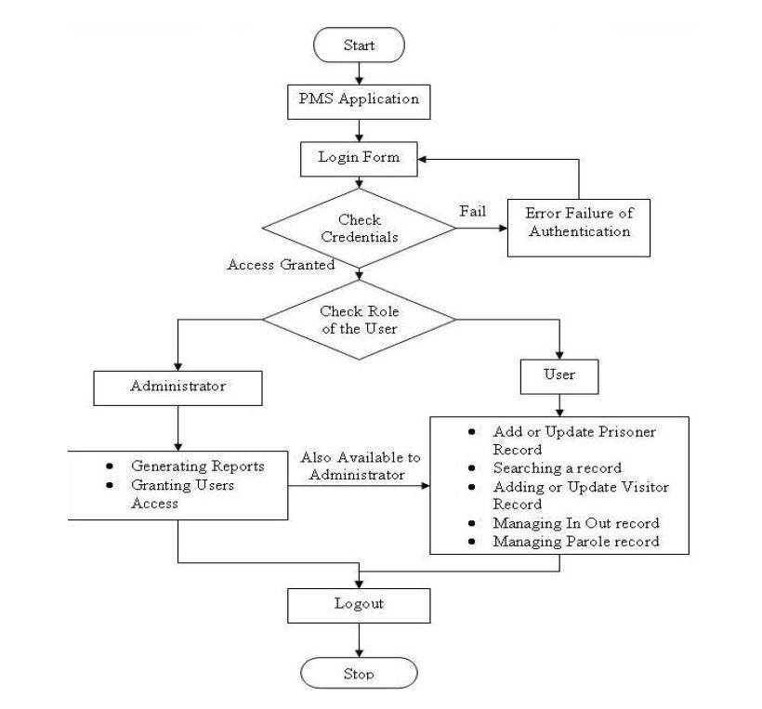

Fig 4.9 System flowchart: As seen in the diagram above the flowchat represent the order in which the program would be executed.

4.9 CHOICE OF PROGRAMMING LANGUAGE
The new system is implemented using PhP programing languate. This is because the programming language has the advantage of easy development, Flexibility and it has the ability of providing the developer/programmer with possible hints and it produces a graphical user interface.

CHAPTER FIVE
SYSTEM IMPLEMENTATION AND TESTING
System implementation is the process of defining the user requirements and designing a system to meet them. Testing on the other hand is the process of testing the newly developed system to ensure the hardware and the operating software is properly installed and configured ensuring other system parameters are properly established.

5.1 SYSTEM REQUIREMENTS
In order to realize this project, the following software and hardware components were used:
5.1.1 Hardware Requirements
In the cost of the design, the software developed required the following hardware for an effective and efficient operation of the new system.
- Pentium IV • 1GB RAM.
- Enhanced keyboard.
- At least 40GB hard disk.
- E.G.A/V.G.A, a colored monitor.
- An uninterruptible power supply (UPS) units • LaserJet or Desk Jet printer.

5.1.2 Software Requirements
The software requirements includes:
- A window 98 or higher version for faster processing
- Wamp server 2.0
- Adobe Dreamweaver cs 5 or higher version
- Adobe flash player

5.2 SYSTEM MODULE IMPLEMENTATION
The system was designed using Top – Down Approach. It makes use of the fundamental program solving techniques. The software is structured in such a way that each subsystem is selected and executed independently. The task is divided into several modules, which come together to give the solution to the problem.

    - Main Home Page
This is the official wage of the Nigerian prison service that allows a user access to the management system. This page would also contain other information and news about the Nigerian Prison Service. This page is accessible to the general public and would require a username and password to access the prison management system as seen below;
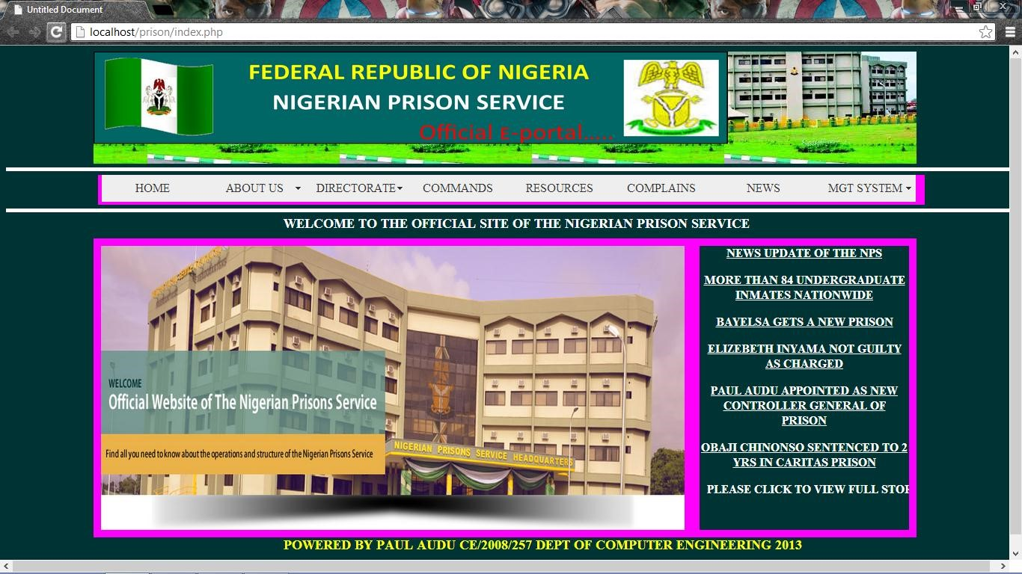
Fig 5.1 home page module implementation: as seen in the diagram above this module is the implementation of the design details in fig 4.5
    - Login Page
This provides a security feature that allows a user to gain access into the prison management system as seen below;
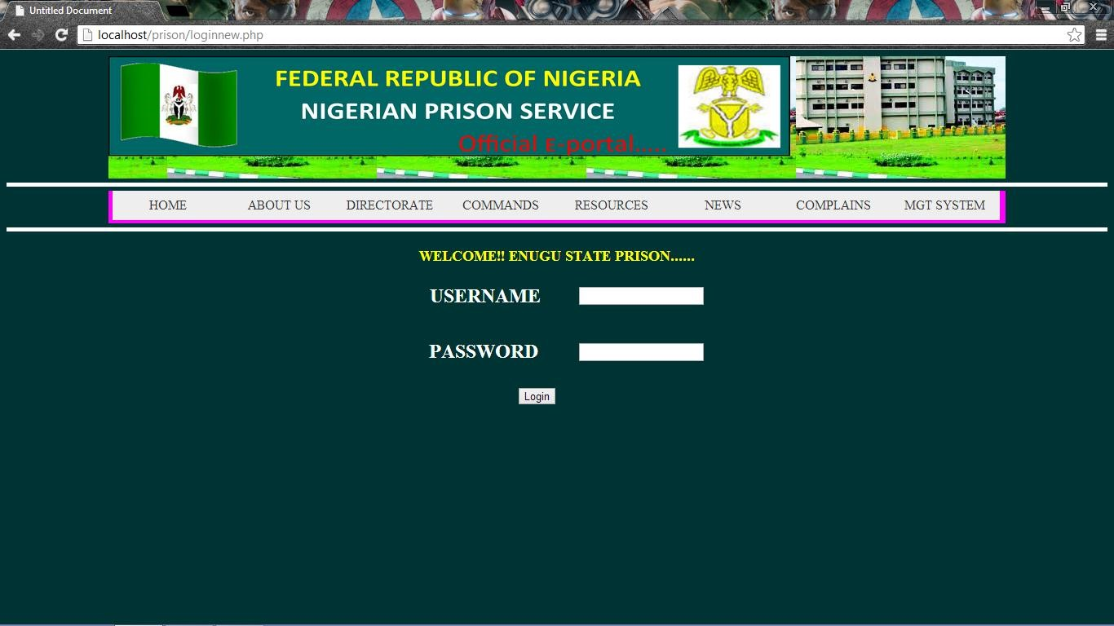
Fig 5.2 Login Page module implementation: As seen in the diagram above this module is the implementation of the design in fig 5.6

    - Management Home Page
This module allows users access to the home page of the management and
authentication details have been verified. This is where prisoner details are managed as seen in the diagram below;
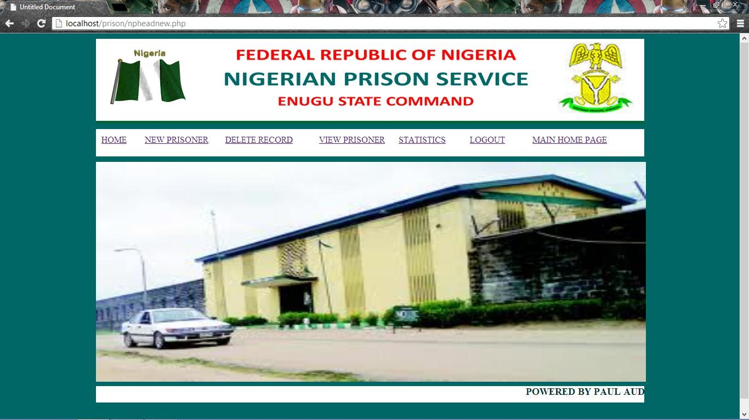
Fig 5.3 Management home page module implementation: As seen in the diagram above this module is the implementation of the design in fig 4.7

    - New Prisoner Registration
This module that allows the user to store a new prisoner case records in a database. These records help in tracking prisoner information at any time. Also it is from this records stored that the reports can be generated from as seen in the diagram below;
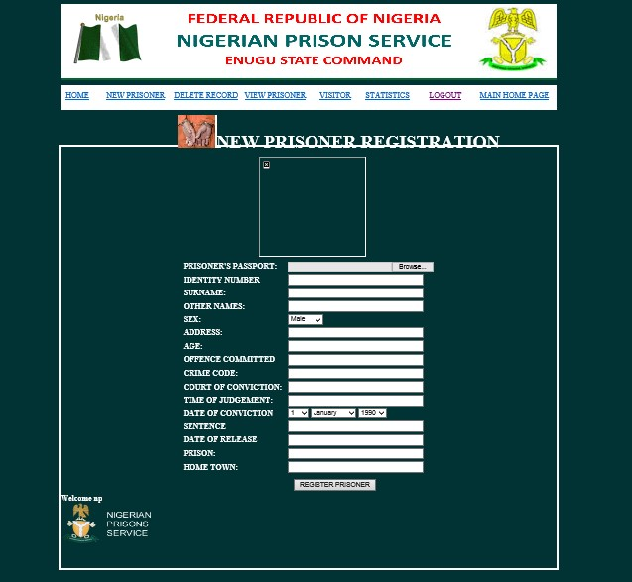
Fig 5.4 home page module implementation: As seen in the diagram above this module is the implementation of the design in fig 4.8
    - Delete Prisoner
This module allows a user to delete a prisoner record.
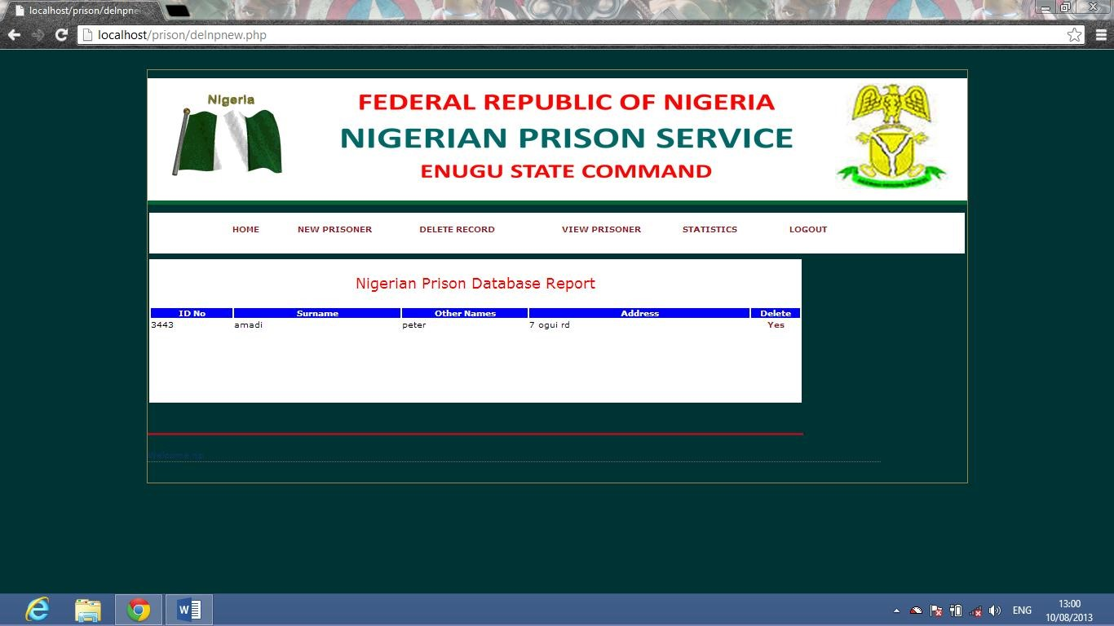
Fig 5.5 Delete page module implementation: As seen in the diagram above this module is the implementation of the design in fig 4.9

    - VIEW PRISONER
This module allows a user to view a prisoner records
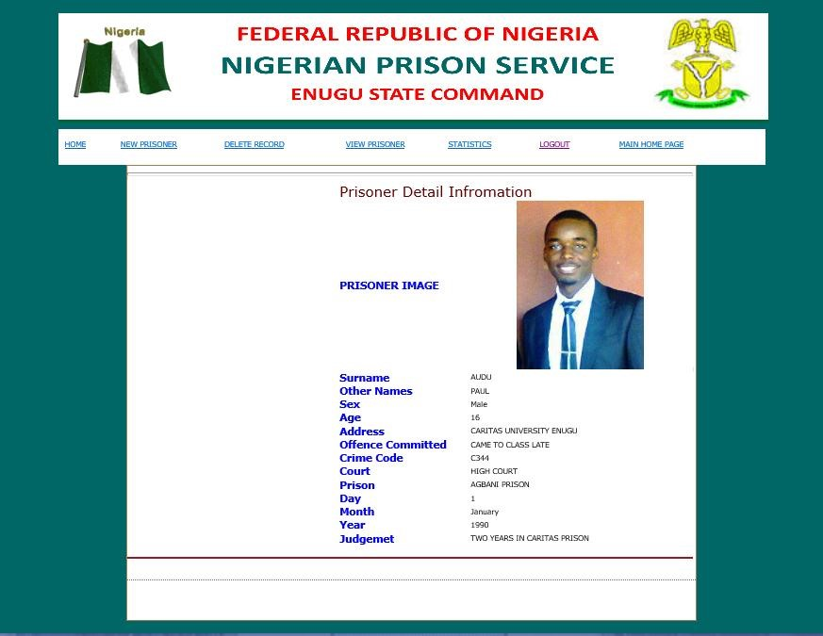
Fig 5.6 View prisoner page module implementation: as seen in the diagram above this module is the implementation of the design in fig 4.10
  - SYSTEM TESTING
After the integration of modules , the whole system was tested. The online prison management system was tested using a local host and it worked properly. Sample prisoner details were imputed into the system and it was stored in the database and viewed using the view prisoner module.

  - BILL OF ENGINEERING MEASUREMENT AND EVALUATION (BEME)
ITEMS | AMOUNT
Cost of transportation during project research | 7,000
Feeding during research | 5000
SOFTWARE used MySQL,PhP,CSS and  Dreamweaver | 20000
Cost of online research | 6000
An HP laptop | 80,000
TOTAL | 118,000
Table 5.1 Bill of Engineering Measurement and Evaluation (BEME)
CHAPTER SIX

SUMMARY, CONCLUSION AND RECOMMENDATIONS

6.1 SUMMARY
It has now become essential to embrace the new technologies in the area of Information and Communication Technology (ICT) for the development ,
modernization, advancement of prisons. Internetworking of all the jails across Nigeria for sharing of information related to prison inmates who had been lodged in various jails of the country should improve the law and order within the state.
It is recommended that Enugu State Prisons be pioneer in this area and they have shown it through their IT setup, a role model for other states and even other countries.
It is likely that this may be replicated in the whole country.

6.2 CONCLUSION
Management of prisons as well as prison records is a vital aspect in the national security which becomes all the more important in the current volatile security situation. Prison management in Nigeria is still in a nascent stage using manual system of files and folders to store and organize prison record. This system is inefficient as well as looking up of specific information is cumbersome and tedious. This greatly impedes the flow of critical information. All these deficiencies are removed using the online Prison Management System. PMS effectively stores all the information in neat prison profiles which have all the necessary information about a prisoner as well as his/her finger print signature attached with the profile. ID numbers can be used as a search key to identify prison records by comparing them with external database that are found at crime scene. All these improvements greatly reduce the time at which specific information is delivered to concerned agencies.

6.3 RECOMMENDATIONS
Currently the Prison Management System can only be deployed for a single prison. But the system has the scope to be developed as a distributed application where each implementation of PMS in different prisons can be connected and communicate with each other. In such a scenario a person sitting in Enugu prison can access the data of Abuja central jail. This will make the whole system highly centralized as well as well connected. This will provide the end user who has the necessary security clearance a single portal where he/she can access prison records from all major prisons in Nigeria where the PMS would be deployed thus making it a truly practical deployable application which can be used in prisons all over Nigeria.

REFERENCES
Aderind, A. & Stepheny, P. (2001). Human Resource Management fifth edition. Australia: Australian Press.
Alan, P. (2004). Human Resource Management in a Business Context. London: Pearson Publication Limited.
Borrington, D. (2005). Human Resource Management seventh edition. London: Pearson Education Limited.
Bratton, J. & Gold P. (2003). Human Resource Management: Theory and Practice.
London: Palgrave Macmillan.
David, A. & Stephen, P. (1996). Human Resource Management fifth edition. Canada:
John Wiley & Sons Inc.
Davide, J. & Gold P. (1994). Human Resource Management: Theory and Practice.
London: Palgrave Macmillan.
Petersin, P. (2000). Computerization of management systems and records. London:
Pearson Publication Limited.
Storey, J. (1995). Human Resource Management: A critical text. London: Routledge Publishers.
Torrington, D. (2005). Human Resource Management sixth edition. London: Pearson Education Limited.

APPENDIX A SOURCE CODE
<!DOCTYPE html PUBLIC "-//W3C//DTD XHTML 1.0 Transitional//EN"
"http://www.w3.org/TR/xhtml1/DTD/xhtml1-transitional.dtd">
<html xmlns="http://www.w3.org/1999/xhtml">
<head>
<meta http-equiv="Content-Type" content="text/html; charset=utf-8" />
<title>Untitled Document</title>
<!-- Start WOWSlider.com HEAD section -->
<link rel="stylesheet" type="text/css" href="engine1/style.css" />
<script type="text/javascript" src="engine1/jquery.js"></script>
<!-- End WOWSlider.com HEAD section -->
<style type="text/css">
#topbar {
background-color: #FFF; height: 150px; width: 1100px; margin-right: auto; margin-left: auto;
background-image: url(images/gghg.jpg); background-position: right center; filter: Glow(Color=green, Strength=3);
}
#pixholder {
height: 150px; width: 200px; float: right;
}
#navbar {
height: 50px; width: 1350px; border-top-width: thick; border-bottom-width: thick; border-top-style: solid; border-bottom-style: solid; border-top-color: #FFF; border-right-color: #FFF; border-bottom-color: #FFF; border-left-color: #FFF; margin-top: 5px; margin-right: auto; margin-bottom: auto; margin-left: auto;
}
#menuholder { background-color: #096; height: 40px; width: 1105px; margin-top: 10px; margin-right: auto;
margin-bottom: 10px; margin-left: auto;
}

#bodywrapper { background-color: #FF0; height: 500px; width: 1100px; margin-top: 10px; margin-right: auto; margin-bottom: auto;
margin-left: auto;
}
#welcometag {
height: 30px; width: 1100px; background-color: #033; margin-top: 5px; margin-right: auto; margin-bottom: auto; margin-left: auto; color: #FFF; font-weight: bolder;
font-size: 18px;
}
#leftmenu { background-color: #0F0; float: left; height: auto; width: 200px;
}
#slideshow { background-color: #F0F; height: auto; width: 700px;
}
#right menu { background-color: #090; float: right; width: 200px;
}
#rightmeun { background-color: #9C0; float: right; height: auto; width: 200px;
}
#left {
color: #F0F; background-color: #00F; height: auto; width: 200px;
}
#body {
background-color: #096;
margin: auto; height: 400px; width: 1100px;
background-repeat: no-repeat;
}
#footer {
margin: auto; height: 40px; width: 1100px; background-color: #033; color: #FF0; font-size: 18px; font-weight: bolder;
text-align: center;
}
#news {
float: right; height: 380px; width: 280px; margin: 10px; text-align: center; background-color: #033; font-weight: bolder;
text-transform: uppercase; color: #FFF;
text-decoration: underline;
}
#slides {
float: left; height: 380px; width: 780px; margin: 10px;
}
</style>
<script src="SpryAssets/SpryMenuBar.js" type="text/javascript"></script>
<link href="SpryAssets/SpryMenuBarHorizontal.css" rel="stylesheet" type="text/css" />
<style type="text/css"> a:link {
color: #FFF;
text-decoration: none;
} a:hover {
color: #F0F;
text-decoration: underline;
} a:visited {
text-decoration: none;
} a:active {
text-decoration: none; color: #00F;
}
</style>
</head>
<body bgcolor="#003333">

<div id="topbar">
<img src="images/official logo.png" width="884" height="143" />
</div>

<div id="navbar">
<div id="menuholder">
<ul id="MenuBar1" class="MenuBarHorizontal">
<li><a href="#">HOME</a></li>
<li><a href="#" class="MenuBarItemSubmenu">ABOUT US</a>
<ul>
<li><a href="#">HISTORY OF NPS</a></li>
<li><a href="#">STATISTICAL INFORMATION</a></li>
<li><a href="#">ROLE OF HONOUR</a></li>
</ul>
</li>
<li><a href="#" class="MenuBarItemSubmenu">DIRECTORATE</a>
<ul>
<li><a href="#">OPERATIONS</a></li>
<li><a href="#">HEALTH AND SOCIAL WELFARE</a></li>
<li><a href="#">INMATES TRAINING AND PRODUCTIVITY</a></li>
<li><a href="#">WORK AND LOGISTICS</a></li>
<li><a href="#">FINANCE AND ACCOUNTS</a></li>
</ul>
</li>
<li><a href="#">COMMANDS</a></li>
<li><a href="#">RESOURCES</a></li>
<li><a href="#">COMPLAINS</a></li>
<li><a href="#">NEWS</a></li>
<li><a href="#" class="MenuBarItemSubmenu" > MGT SYSTEM</a> <ul>
<li><a href="loginnewadmin.php">ADMINISTRATOR</a></li>

<li><a href="loginnewfct.php">FCT ABUJA</a></li>
<li><a href="#">ABIA STATE</a></li>
<li><a href="#">ADAMAWA STATE</a></li>
<li><a href="#">AKWA IBOM</a></li>
<li><a href="#">ANAMBRA</a></li>
<li><a href="loginnew.php">ENUGU STATE</a></li>
<li><a href="#">ZAMFARA STATE</a></li>
<li><a href="#">RIVERS STATE</a></li>
<li><a href="#">KOGI STATE</a></li>
<li><a href="#">BAYELSA STATE</a></li>
<li><a href="#">KADUNA STATE</a></li>
<li><a href="#">OYO STATE</a></li>
</ul>
</li>
</ul>
</div>
</div>

<div id="welcometag">
<marquee>WELCOME TO THE OFFICIAL SITE OF THE NIGERIAN PRISON SERVICE </marquee> </div>

<div id="body">
<div id="news">
NEWS UPDATE OF THE NPS
<p> <a href="news1.php">MORE THAN 84 UNDERGRADUATE INMATES NATIONWIDE</a><P>
<p> <a href="news1.php">BAYELSA GETS A NEW PRISON</a><P>
<p> <a href="news1.php">ELIZEBETH INYAMA NOT GUILTY AS CHARGED</a><P>
<p> <a href="news1.php">PAUL AUDU APPOINTED AS NEW CONTROLLER GENERAL OF PRISON</a><P>
<p> <a href="news1.php">OBAJI CHINONSO SENTENCED TO 2 YRS IN CARITAS PRISON</a><P> <p> <a href="news1.php"><marquee>Please click to view full story</marquee></a><P>
</div>

<div id="slides">
<!-- Start WOWSlider.com BODY section -->
<div id="wowslider-container1">
<div class="ws_images"><ul>
<li><img src="data1/images/slide1.jpg" alt="slide1" width="80%" height="376" id="wows1_0" title="slide1"/></li>
<li><img src="data1/images/slide2.jpg" alt="slide2" width="80%" height="376"title="slide2" id="wows1_1"/></li>
<li><img src="data1/images/slide3.jpg" alt="slide3" width="80%" height="376"title="slide3" id="wows1_2"/></li>
<li><img src="data1/images/slide4.jpg" alt="slide4" width="80%" height="376"title="slide4" id="wows1_3"/></li>
<li><img src="data1/images/slide5.jpg" alt="slide5" width="80%" height="376"title="slide5" id="wows1_4"/></li>
<li><img src="data1/images/slide6.jpg" alt="slide6" width="80%" height="376"title="slide6" id="wows1_5"/>ENUGU PRISON COMMAND</li> <li><img src="data1/images/slide7.jpg" alt="slide7" width="80%" height="376"title="slide7" id="wows1_6"/></li>
</ul></div>
<div class="ws_bullets"><div>
<a href="#" title="slide1"><img src="data1/tooltips/slide1.jpg" alt="slide1"/>1</a>
<a href="#" title="slide2"><img src="data1/tooltips/slide2.jpg" alt="slide2"/>2</a>
<a href="#" title="slide3"><img src="data1/tooltips/slide3.jpg" alt="slide3"/>3</a>
<a href="#" title="slide4"><img src="data1/tooltips/slide4.jpg" alt="slide4"/>4</a>
<a href="#" title="slide5"><img src="data1/tooltips/slide5.jpg" alt="slide5"/>5</a>
<a href="#" title="slide6"><img src="data1/tooltips/slide6.jpg" alt="slide6"/>6</a> <a href="#" title="slide7"><img src="data1/tooltips/slide7.jpg" alt="slide7"/>7</a> </div></div>
<span class="wsl"><a href="http://wowslider.com">Javascript Slideshow</a> by
WOWSlider.com v4.3</span>
<div class="ws_shadow"></div>
</div>
<script type="text/javascript" src="engine1/wowslider.js"></script>
<script type="text/javascript" src="engine1/script.js"></script>
<!-- End WOWSlider.com BODY section -->
</div>

</div>

<div id="footer">
POWERED BY PAUL AUDU CE/2008/257 DEPT OF COMPUTER ENGINEERING 2013
</div>

<script type="text/javascript">
var MenuBar1 = new Spry.Widget.MenuBar("MenuBar1", {imgDown:"SpryAssets/SpryMenuBarDownHover.gif", imgRight:"SpryAssets/SpryMenuBarRightHover.gif"});
</script>

</body>
</html>

<!DOCTYPE html PUBLIC "-//W3C//DTD XHTML 1.0 Transitional//EN"
"http://www.w3.org/TR/xhtml1/DTD/xhtml1-transitional.dtd">
<html xmlns="http://www.w3.org/1999/xhtml">
<head>
<meta http-equiv="Content-Type" content="text/html; charset=utf-8" />
<title>Untitled Document</title>

<!-- Start WOWSlider.com HEAD section -->
<link rel="stylesheet" type="text/css" href="engine1/style.css" />
<script type="text/javascript" src="engine1/jquery.js"></script>
<!-- End WOWSlider.com HEAD section -->

<script type="text/javascript" src="jQuery.js"></script>
<script type="text/javascript" src="js.js"></script> <script language="javascript" src="mootools/mootools.svn.js" type="text/javascript"></script>

<style type="text/css">
<!--

#header {
height: 150px; width: 1000px; border-bottom-width: thick; border-bottom-style: solid; border-bottom-color: #063; background-color: #FFF; margin-top: 10px; margin-right: auto; margin-bottom: auto;
margin-left: auto;
}

#navbar {
height: 50px; width: 1000px; margin-top: 10px; margin-right: auto; margin-bottom: auto; margin-left: auto; background-color: #FFF; }
#body image {
margin: auto; height: 400px; width: 1000px;
}
#bodyimage {
height: 400px; width: 1000px; margin-top: 10px; margin-right: auto; margin-bottom: auto;
margin-left: auto;
}
#fotter {
height: 30px; width: 1000px; color: #033; font-size: 18px; font-weight: bolder; margin-top: 0px; margin-right: auto; margin-bottom: auto; margin-left: auto;
background-color: #FFF;
}

#body { background-color: #096; margin: auto; height: 400px; width: 1100px; background-repeat: no-repeat;
}
body { background-image: url(); background-repeat: no-repeat; margin-left: 2px; margin-top: 2px; margin-right: 2px; margin-bottom: 2px;
background-color: #066;
}
.tablestyle { background-color: #033;
}
#news {
float: right; height: 380px; width: 280px; margin: 10px; text-align: center; background-color: #033; font-weight: bolder; text-transform: uppercase; color: #FFF;
text-decoration: underline;
}
#img holder {
margin: auto; float: left; height: 400px;
width: 750px;
}
#slides {
float: left; height: 380px; width: 780px; margin: 10px;
}

#imgsld {
margin: auto; float: left; height: 400px; width: 800px;
}
#news {
float: right; height: 380px; width: 280px; margin: 10px; text-align: center; background-color: #FFF; font-weight: bolder; text-transform: uppercase; color: #FFF;
text-decoration: underline;
}
-->
</style>

</head>

<body>
<div id="header">
<table width="968" height="142" align="center">
<tr>
<td width="163" bgcolor="#FFFFFF"><img src="images/nigeria[1].gif" width="155" height="127" /></td>
<td width="655"><img src="images/Picture21.png" width="655" height="126" /></td>
<td width="152"><img src="images/hhbh.jpg" width="139" height="130" /></td>
</tr>
</table>
</div>

<form id="userForm" name="userForm" method="post" action="">
<input name="username" type="hidden" id="username" value="np" />
<input name="password" type="hidden" id="password" value="admin" /> <div id="navbar">
<table width="985" height="41" align="center">
<tr>

<td width="78"><a href="#" onclick="adminTransfer('npheadnew.php');">HOME</a></td>
<td width="132"><a href="#" onclick="adminTransfer('npregnew.php');">NEW PRISONER </a></td>
<td width="138"> <a href="#" onclick="adminTransfer('delnpnew.php');"> DELETE RECORD </a></td>
<td width="147"><a href="#" onclick="adminTransfer('viewnpnew.php');"> VIEW PRISONER </a></td>
<td width="88"><a href="#" onclick="adminTransfer('visitor.php');">VISITOR </a></td>
<td width="124"><a href="#" onclick="adminTransfer('viewnpnew.php');">
STATISTICS</a></td>
<td width="98"><a href="loginnew.php">LOGOUT</a></td>
<td width="144"> <a href="index.php"> MAIN HOME PAGE </A>
</tr>
</table>

</div>
</form>

<div id="body" >
<div id="news">
NEWS UPDATE OF THE NPS
<p > <a href="news1.php">MORE THAN 84 UNDERGRADUATE INMATES NATIONWIDE</a><P>
<p> <a href="news1.php">BAYELSA GETS A NEW PRISON</a><P>
<p> <a href="news1.php">ELIZEBETH INYAMA NOT GUILTY AS CHARGED</a><P>
<p> <a href="news1.php">PAUL AUDU APPOINTED AS NEW CONTROLLER GENERAL OF PRISON</a><P>
<p> <a href="news1.php">OBAJI CHINONSO SENTENCED TO 2 YRS IN CARITAS PRISON</a><P> <p> <a href="news1.php"><marquee>Please click to view full story</marquee></a><P>
</div>

<div id="slides">
<!-- Start WOWSlider.com BODY section -->
<div id="wowslider-container1">
<div class="ws_images"><ul>
<li><img src="data1/images/slide1.jpg" alt="slide1" width="106%" height="376" id="wows1_0" title="slide1"/></li>
<li><img src="data1/images/slide2.jpg" alt="slide2" width="80%" height="376"title="slide2" id="wows1_1"/></li>
<li><img src="data1/images/slide3.jpg" alt="slide3" width="80%" height="376"title="slide3" id="wows1_2"/></li>
<li><img src="data1/images/slide4.jpg" alt="slide4" width="80%" height="376"title="slide4" id="wows1_3"/></li>
<li><img src="data1/images/slide5.jpg" alt="slide5" width="80%" height="376"title="slide5" id="wows1_4"/></li>
<li><img src="data1/images/slide6.jpg" alt="slide6" width="80%" height="376"title="slide6" id="wows1_5"/>ENUGU PRISON COMMAND</li> <li><img src="data1/images/slide7.jpg" alt="slide7" width="80%" height="376"title="slide7" id="wows1_6"/></li> </ul></div>
<div class="ws_bullets"><div>
<a href="#" title="slide1"><img src="data1/tooltips/slide1.jpg" alt="slide1"/>1</a>
<a href="#" title="slide2"><img src="data1/tooltips/slide2.jpg" alt="slide2"/>2</a>
<a href="#" title="slide3"><img src="data1/tooltips/slide3.jpg" alt="slide3"/>3</a>
<a href="#" title="slide4"><img src="data1/tooltips/slide4.jpg" alt="slide4"/>4</a>
<a href="#" title="slide5"><img src="data1/tooltips/slide5.jpg" alt="slide5"/>5</a>
<a href="#" title="slide6"><img src="data1/tooltips/slide6.jpg" alt="slide6"/>6</a> <a href="#" title="slide7"><img src="data1/tooltips/slide7.jpg" alt="slide7"/>7</a> </div></div>
<span class="wsl"><a href="http://wowslider.com">Javascript Slideshow</a> by
WOWSlider.com v4.3</span>
<div class="ws_shadow"></div>
</div>
<script type="text/javascript" src="engine1/wowslider.js"></script>
<script type="text/javascript" src="engine1/script.js"></script>
<!-- End WOWSlider.com BODY section -->
</div>

</div>

<div id="fotter"><marquee>POWERED BY PAUL AUDU CE/2008/257 DEPT OF COMPUTER ENGINEERING
CARITAS UNIVERSITY ENUGU</marquee></div>
<p>&nbsp;</p>
</body>
</html>

